
AMERICAN INTERNATIONAL UNIVERSITY-BANGLADESH
Faculty of Science and Technology
Department of Computer Science
CSC 3215: Web Technologies

Semester: Summer 2025-26 | Group No: |  | Section: | X

Group Members:
SL. | Student ID | Name | Role | Signature
1 | 23-53953-3 | Md Farhan Nadim | Group Leader
2 | 23-54374-3 | Fariha Akter Prity | Member
3 | 23-54396-3 | Arafatullah Rifat | Member
4 | 23-54407-3 | Mashfi Rahman | Member
Project Title
Home Rental Management System ( PropManage)

Short Description
The project will develop a centralized web-based Home Rental Management System for three roles: Tenant, Landlord, and Admin. The system will support property browsing and management, rental requests, payment processing, maintenance tickets, messaging, account verification, user management, payouts, and audit activity tracking through role-based dashboards.
Introduction
The Home Rental Management System is a web-based platform designed to simplify and centralize the rental process for tenants, landlords, and administrators. The system provides role-based access so that each user can perform the activities relevant to their responsibilities. Tenants can search for properties, submit rental requests, make payments, raise maintenance tickets, and communicate with landlords. Landlords can manage properties, review rental requests, manage maintenance activities, track payments, and communicate with tenants. Administrators can verify accounts, manage users, process payouts, and maintain audit records.
Background Study
Rental property management often involves repeated communication and record keeping between tenants, landlords, and administrators. Property information, rental requests, payment records, maintenance issues, and account verification can become difficult to manage when handled manually or through disconnected communication channels. A centralized web system can reduce this complexity by keeping property, booking, payment, maintenance, and user information in one place. The proposed system therefore focuses on improving transparency, reducing manual effort, and making common rental activities easier to track. The current project is organized around three roles, which are Tenant, Landlord, and Admin, and the UI designs reflect separate workflows and dashboards for these roles.
ER Diagram
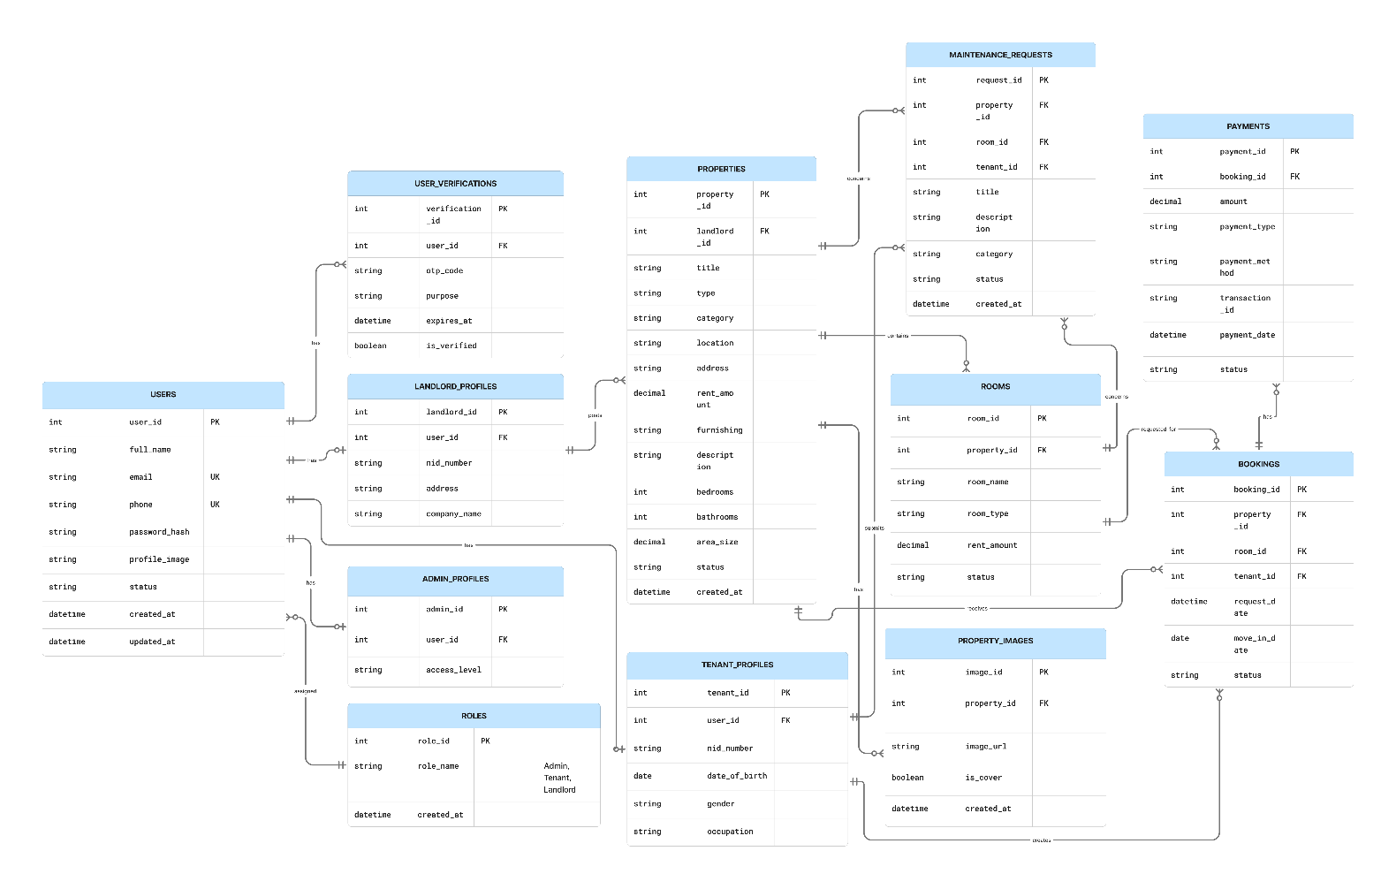
Figure 1: Final ER Diagram of the Home Rental Management System (three roles: Tenant, Landlord, Admin).

Use Case Diagram
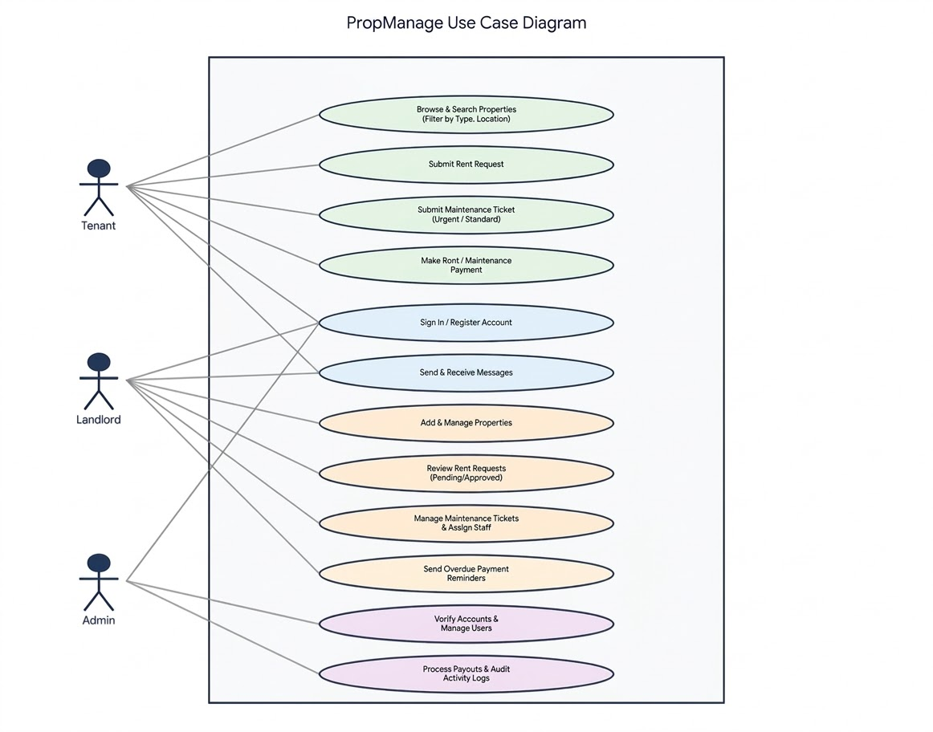
Figure 2: Final Use Case Diagram showing the interactions of Tenant, Landlord, and Admin.

UI (Figma/Sketch)
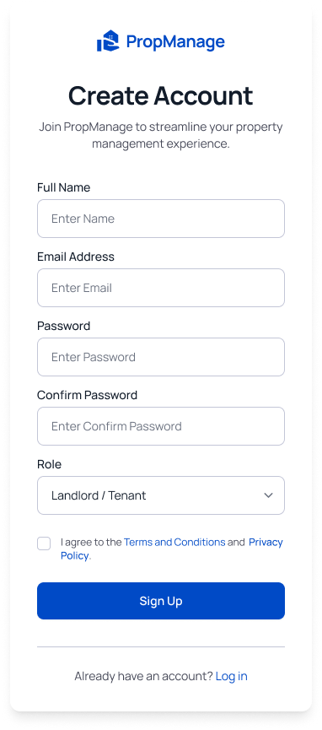
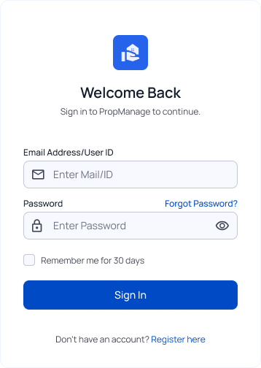
SignIn & SignUp

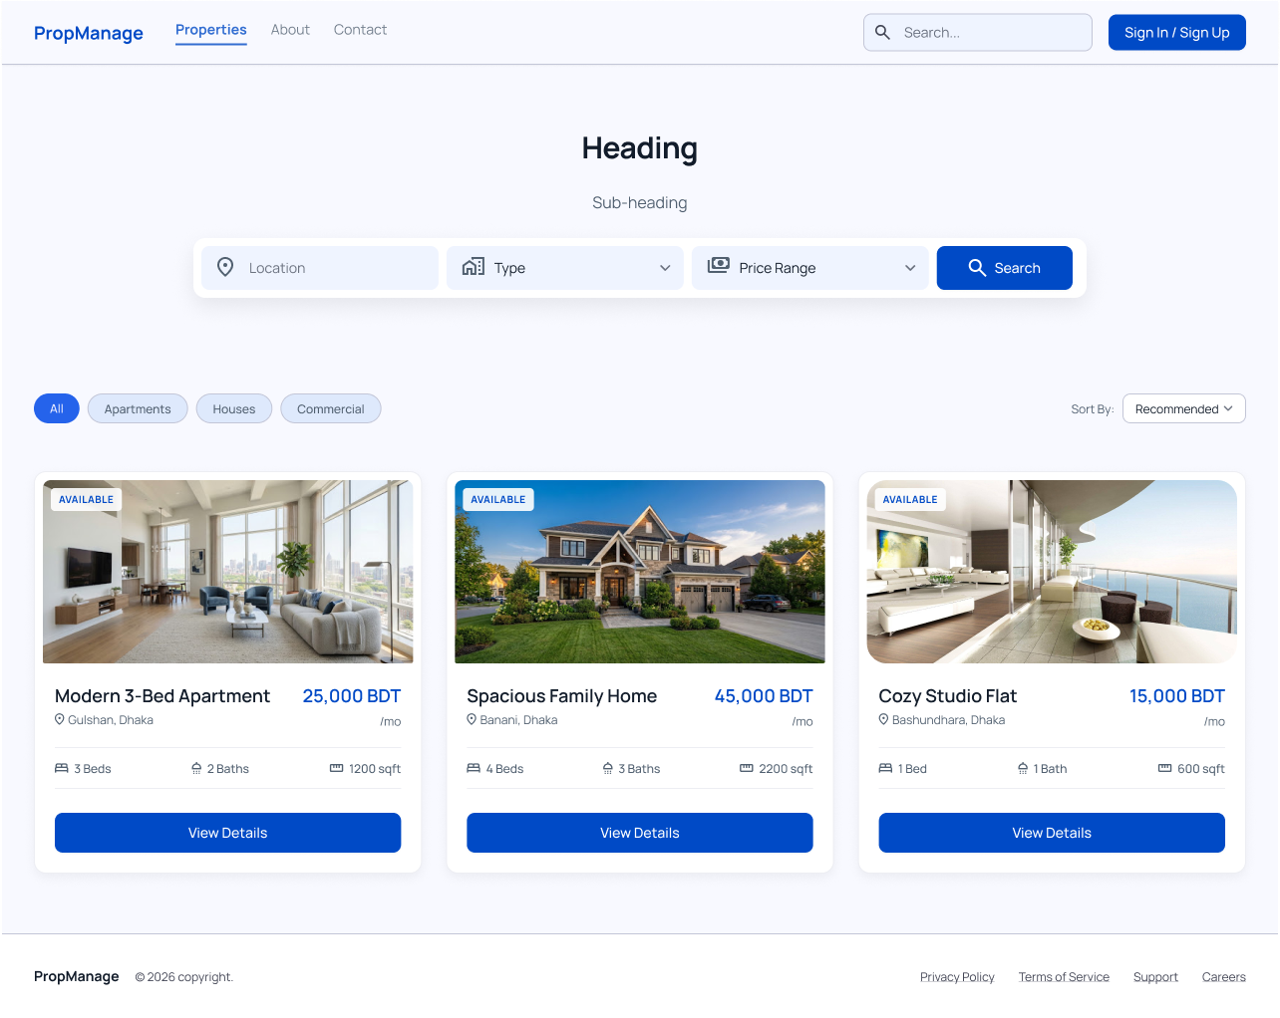
Home Page

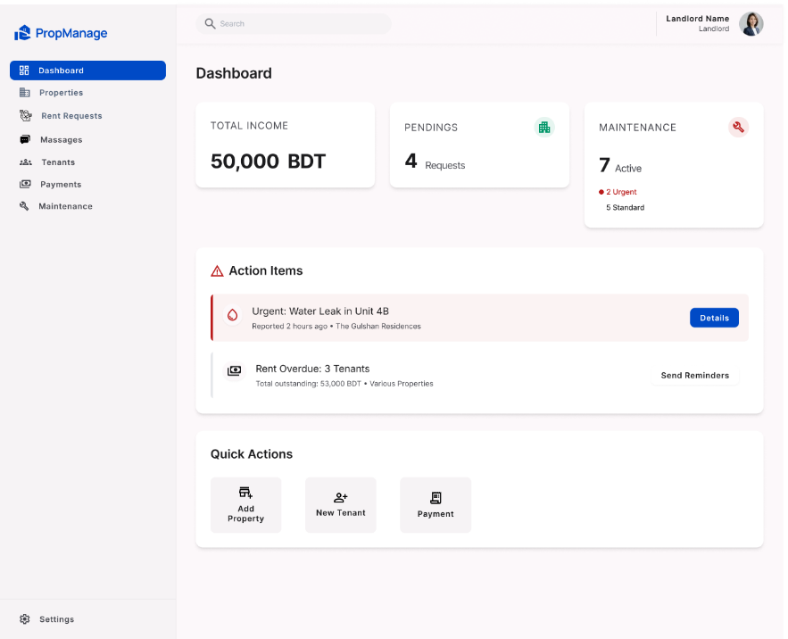
Landlord Features

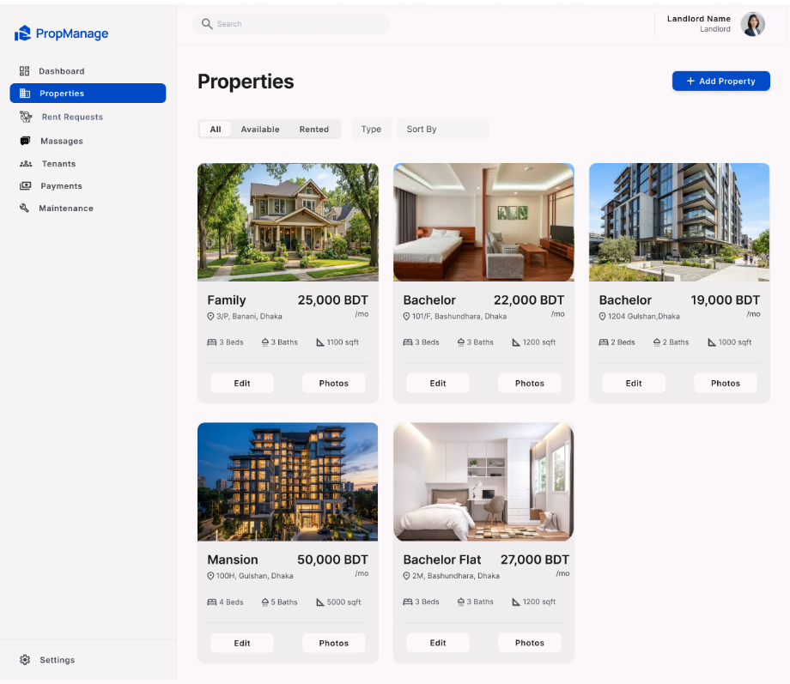

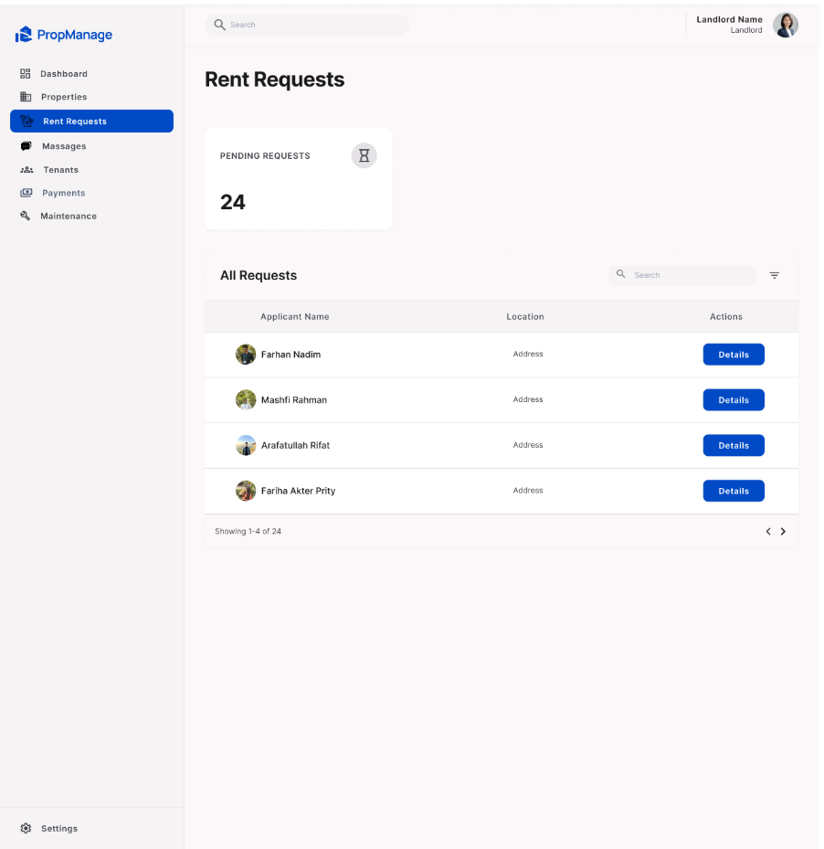
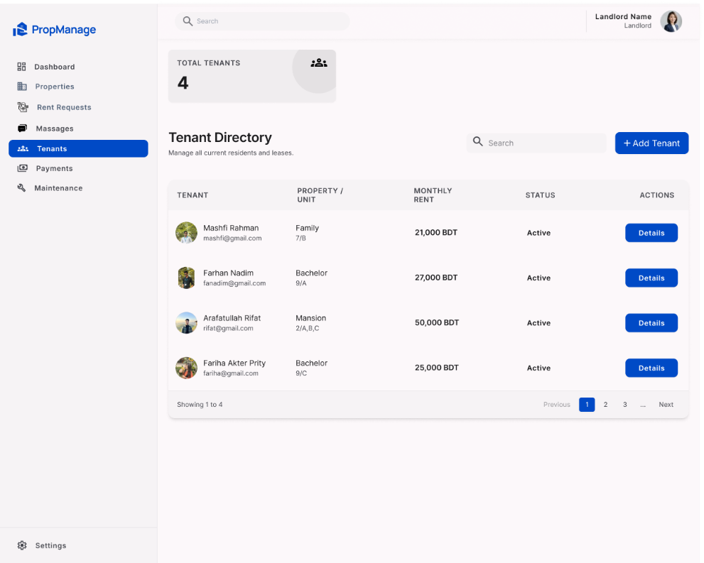

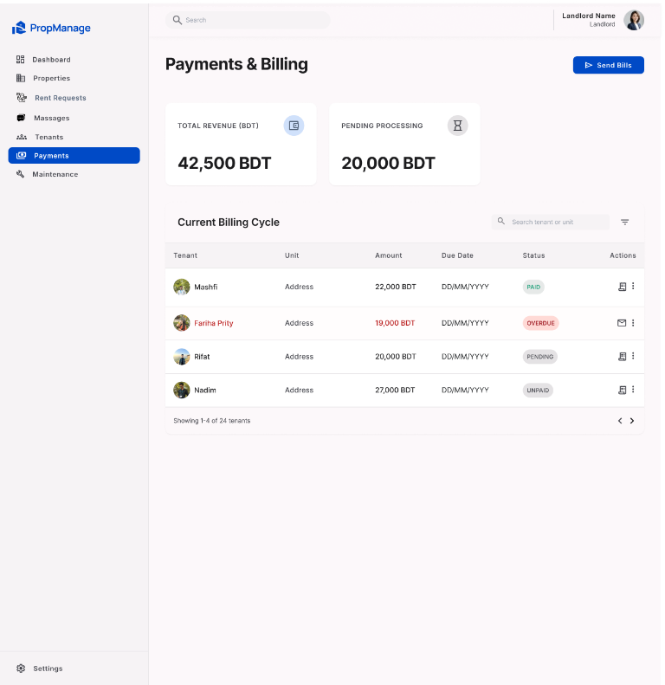

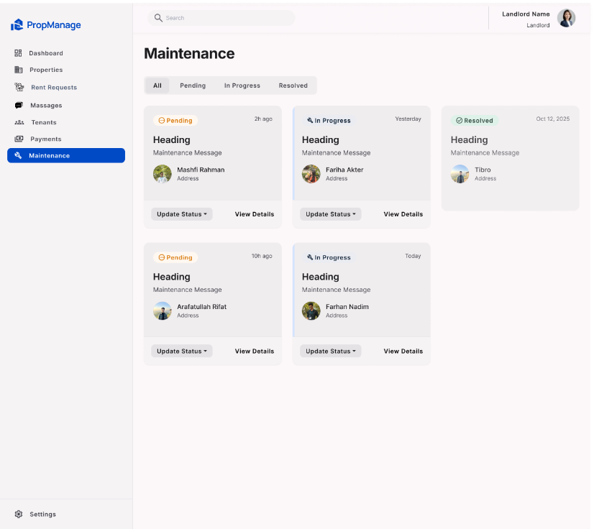

Tenant Features
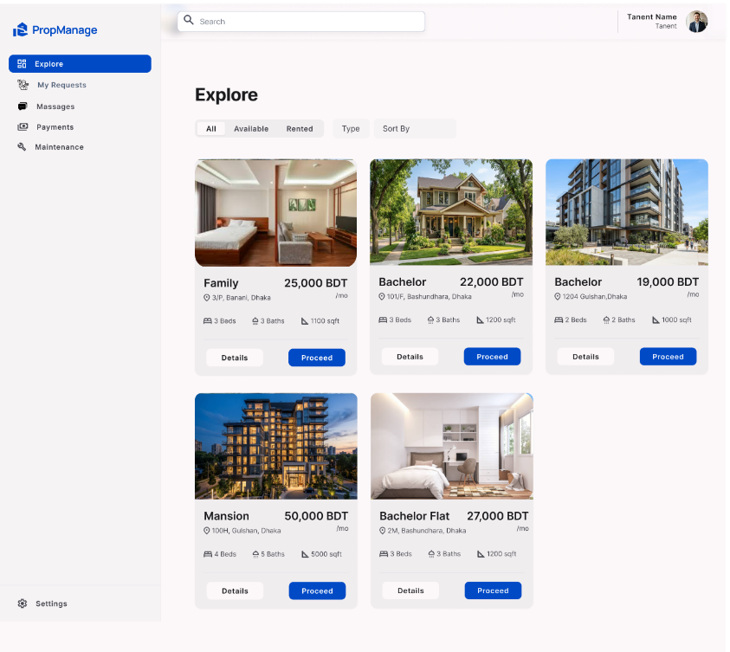

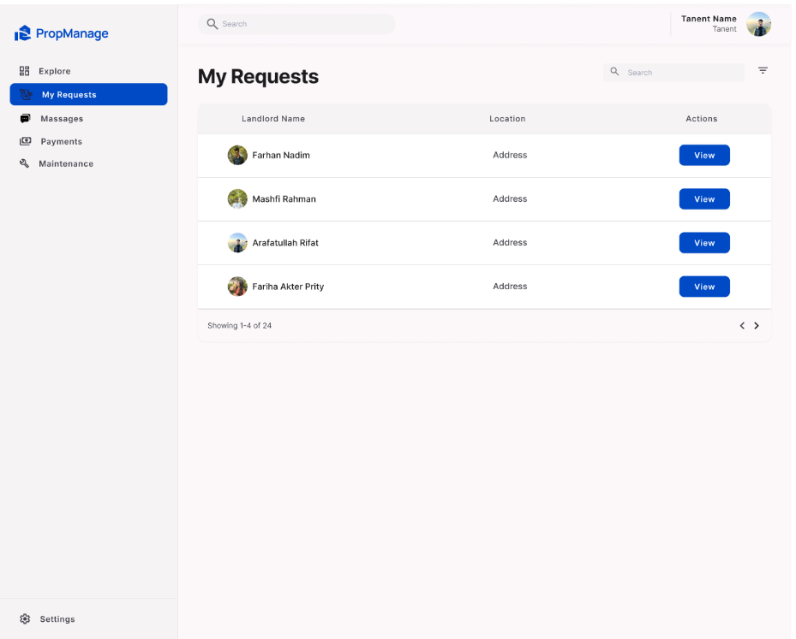

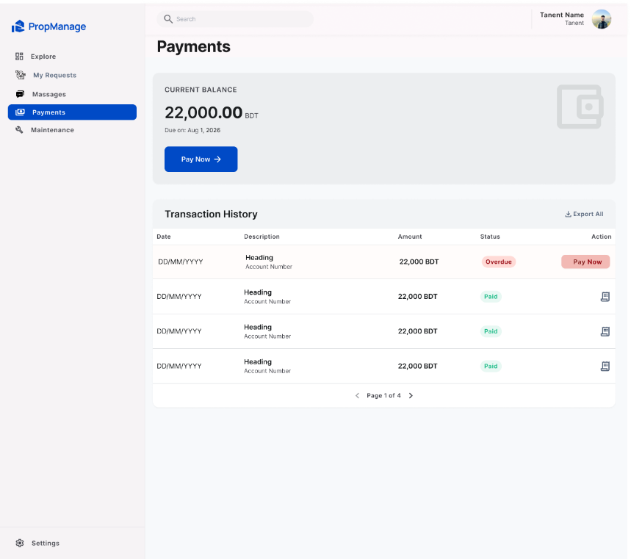

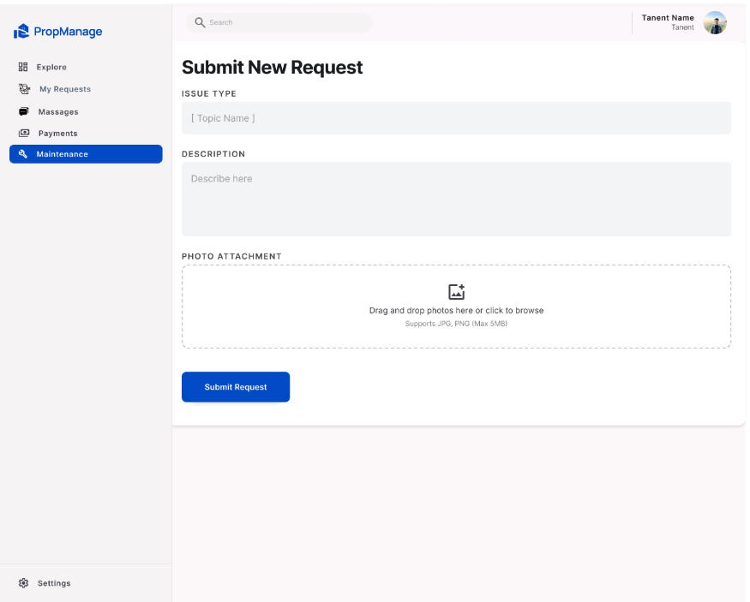

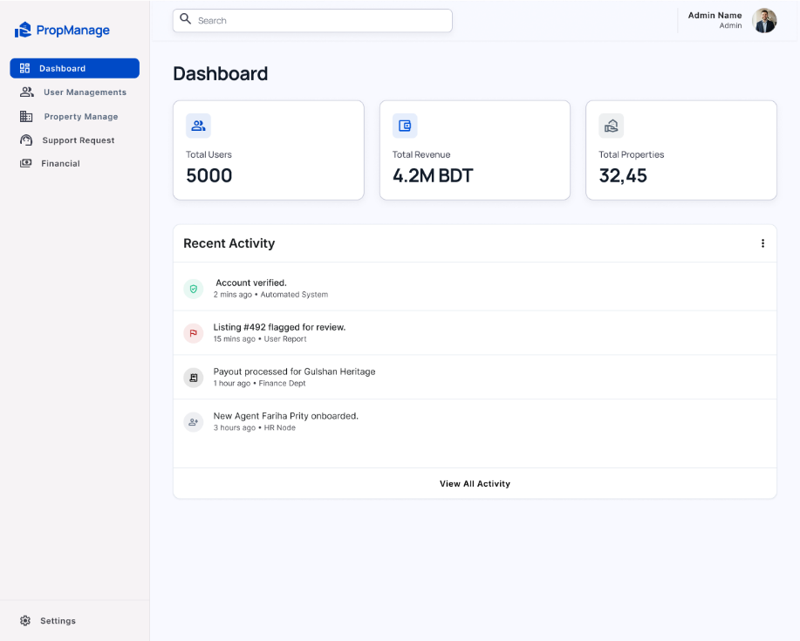

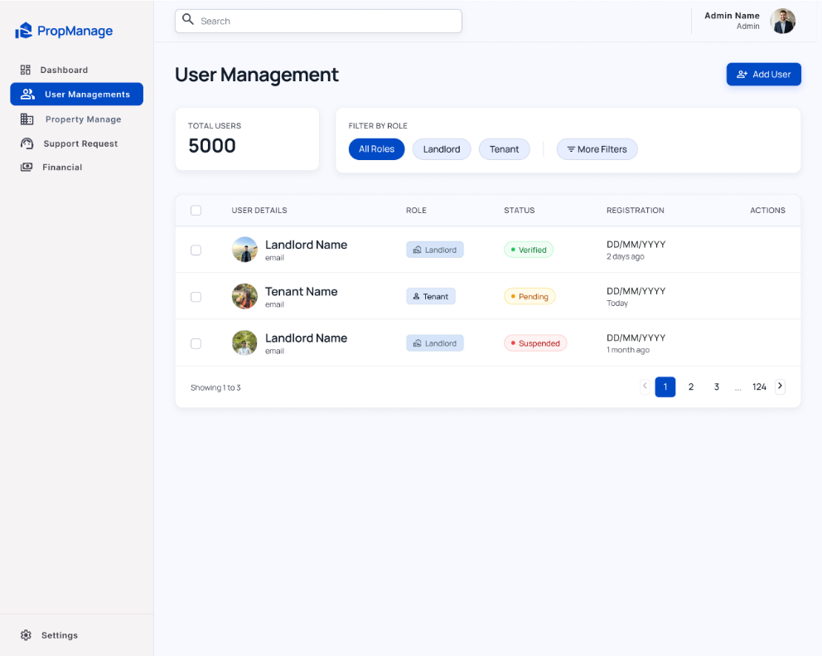

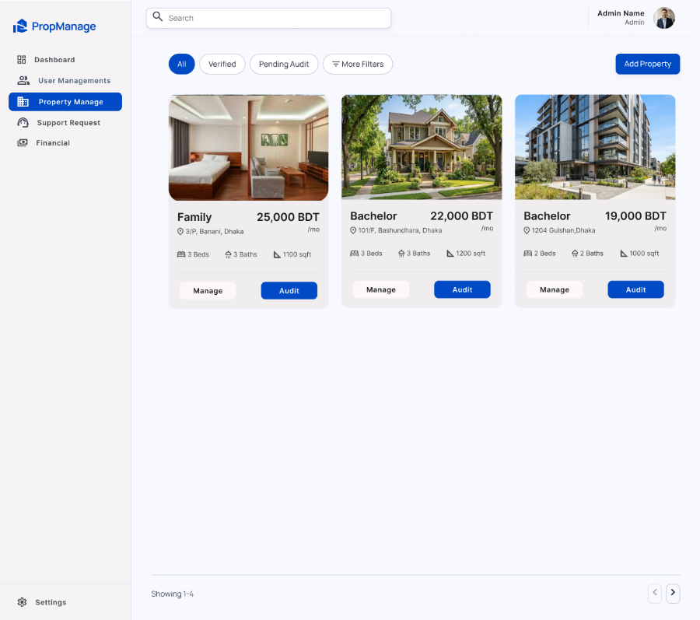

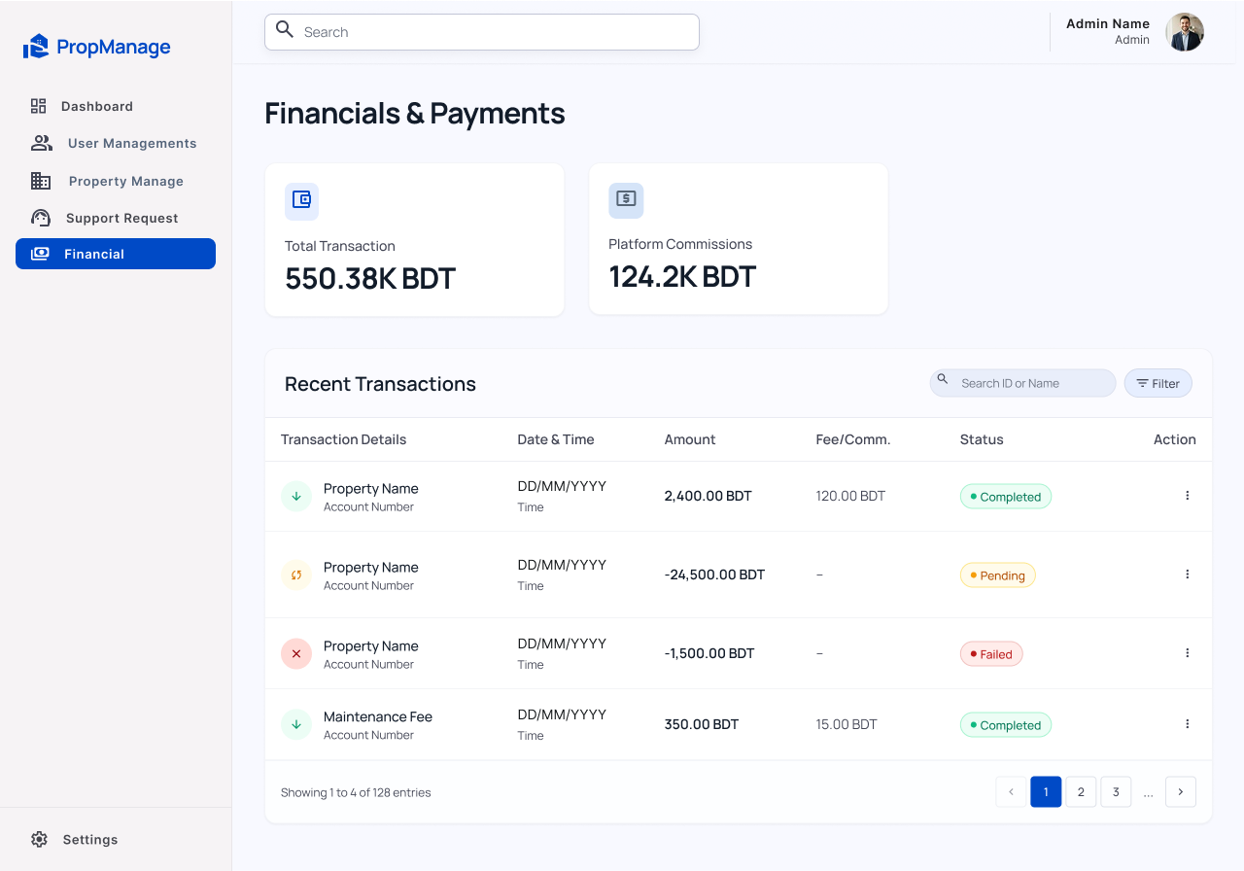

Common Features
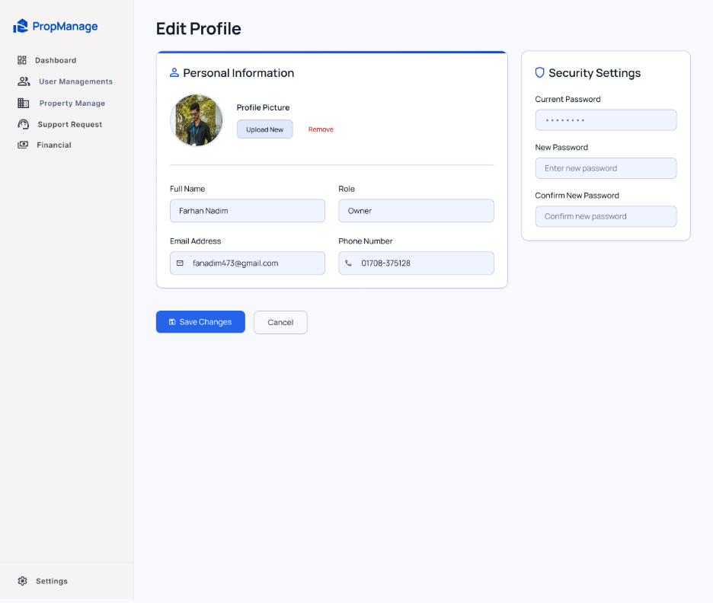

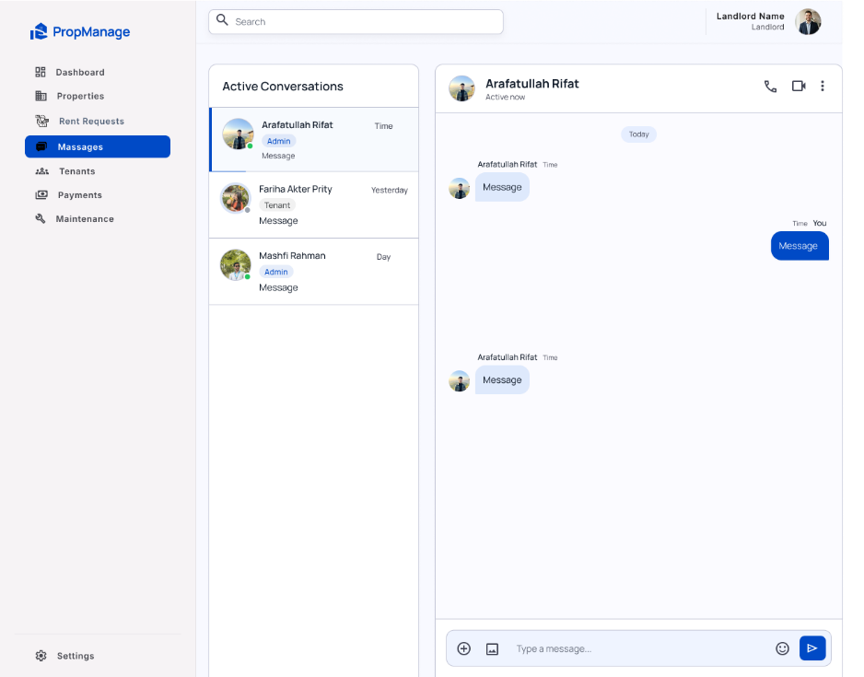

User Type | Specific Features
Types of User | 1. Tenant 2. Landlord 3. Admin
Common Features | Authentication: Login, Logout, User Registration  Account Management: Change/Reset Password; View, Edit, Delete Profile Information  Dashboard: Access a personalized dashboard after login
Tenant | 1. Browse and search rental properties  2. Submit rent requests and track request status  3. Submit maintenance tickets and track their status  4. Make rent/maintenance payments
Landlord | 1. Add and manage rental properties  2. Review and approve/reject tenant rent requests  3. Manage maintenance tickets and assign staff  4. Track rental payments and send overdue payment reminders
Admin | 1. Verify accounts and manage users  2. Process payouts and maintain audit activity logs  3. Manage system-level records and administrative operations

Final System Scope
The final proposal is based on the latest project materials supplied for this version. The system contains exactly three user roles: Tenant, Landlord, and Admin. The final ER diagram, use case diagram, and UI designs are treated as the authoritative design references for this proposal. The system focuses on property discovery and management, rental requests, payments, maintenance tickets, messaging, account verification, user management, payouts, and audit activity.

Github Link: https://github.com/fanadim/WebTech_Final_Project

